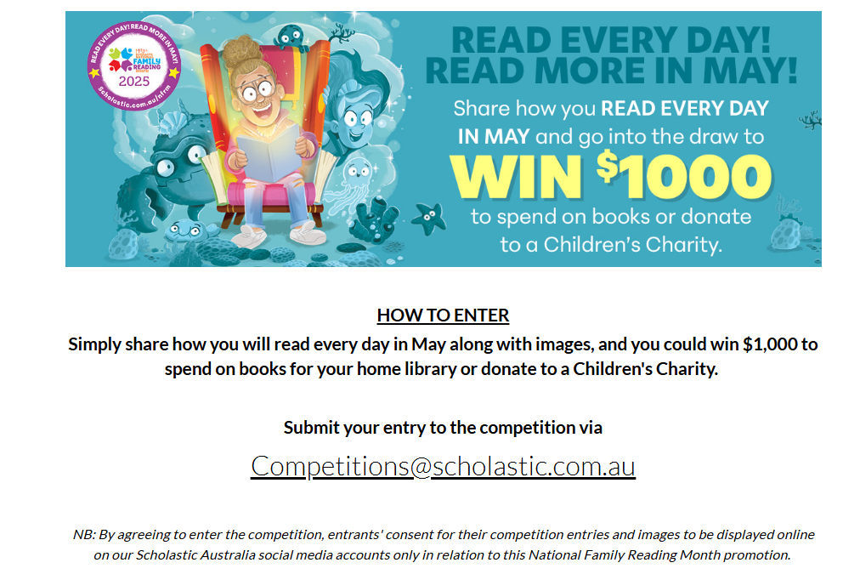

[NFRM2025Incentive4 | Scholastic Australia](https://scholastic.com.au/booksellers/competitions/nfrm2025incentive4) to view information & T&Cs